pcTouch

Installation In Swiftpos Touch POS

- Run PC Touch_4.0.9.exe.
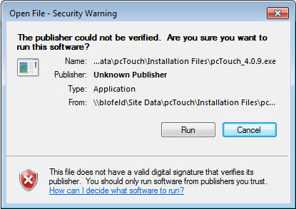

Select Run

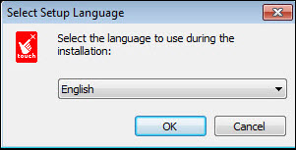

Select a Language and then select Next

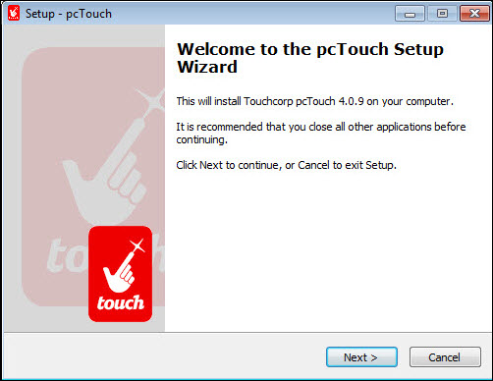

Select Next

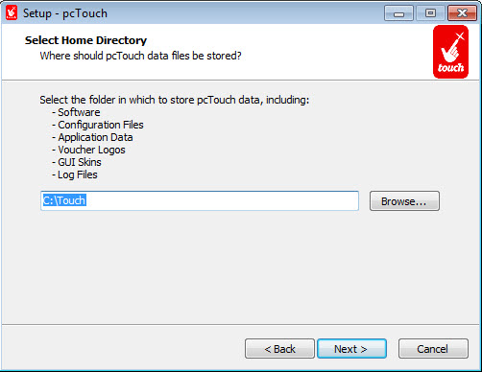

Select Next

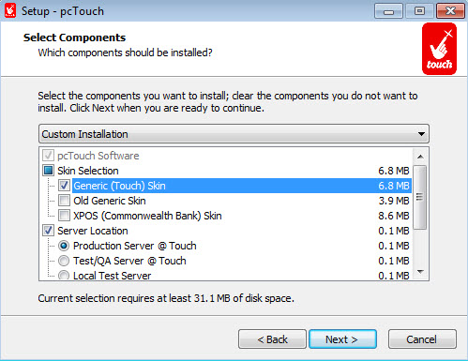

Select Generic (Touch) Skin and select Next

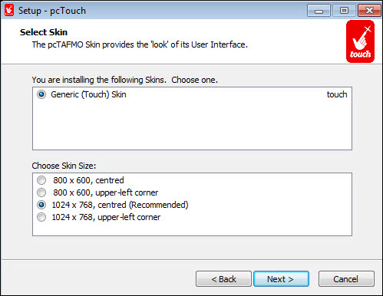

Select Next

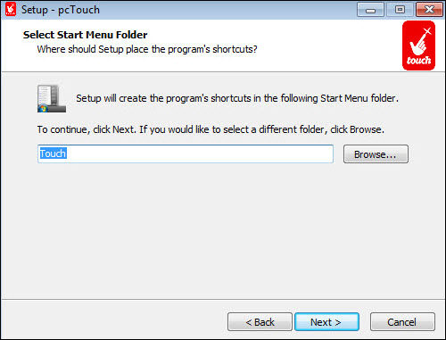

Select Next

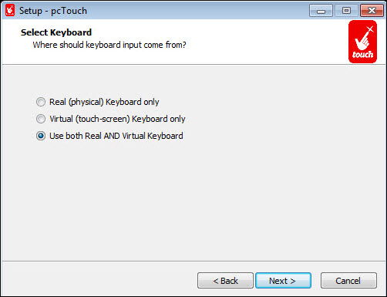

Select Next

Then :

- Install
- (Ok on Error)
- Finish
- Run C:\Touch\PCTAFMO.exe

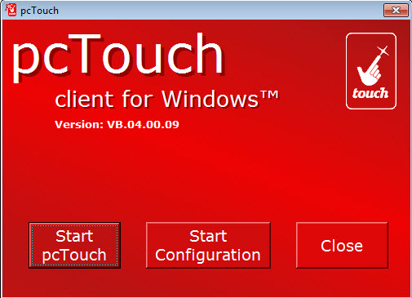

Select Start Configuration

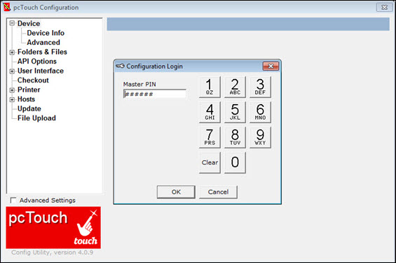

Enter Password (Refer HERE for login credentials) on keyboard - 467263.

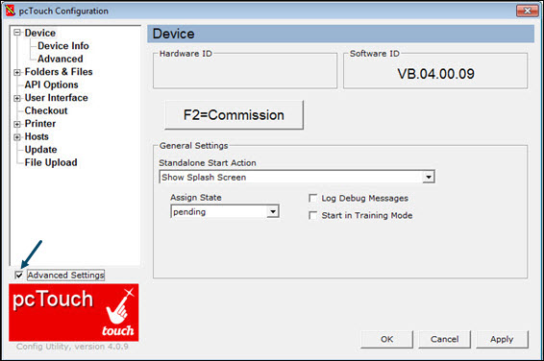

- Select Device
- Select the Advanced Settings option and then select OK

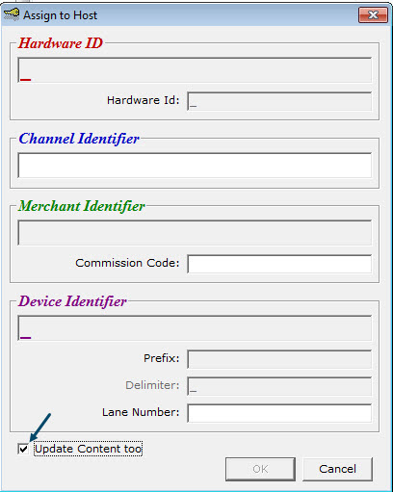

Select F2=Commission

Setup Channel ID: eg: Channel Identifier 5 Digit number
Commission Code:
Lane: eg 01 or 02 etc.
Select Update Content Too and select OK

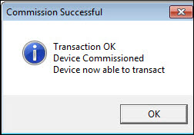

Select OK

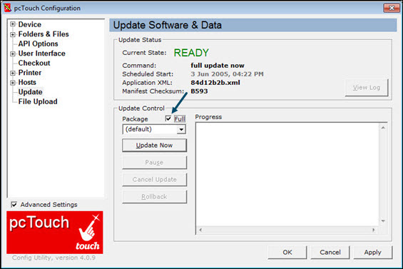

- Select Hosts > Update
- Select the Full option
- Select Update Now and Wait till complete
- Select Apply
- Select OK
- Select Close

If you have any issues, please contact Jasmeet as below:

Jasmeet Walia
Embedded and Operations Manager - Australia
Touchcorp Limited
+61 468 913 350
+61 3 9018 6834
jasmeet.walia@touchcorp.com
www.touchcorp.com

